**UNIVERSITY OF MUMBAI**

A PROJECT REPORT ON

**“Employee DApp “**

SUBMITTED BY

**Mishra Shivam Vivek**

**Vishnu Waman Thakur Charitable Trust’s**

**VIVA INSTITUTE OF TECHNOLOGY Shirgaon, Virar(East)**

**2022-23**

**Vishnu Waman Thakur Charitable Trust’s**

**VIVA INSTITUTE OF TECHNOLOGY**

**Shirgaon, Virar(East)**



**CERTIFICATE**

**This is to certify that**

**Mr. Mishra Shivam Vivek**

**Has satisfactorily completed the project entitled**

**Employee DApp**

**Towards the partial fulfillment of the**

**MASTER OF COMPUTER APPLICATION (MCA)**

**As laid by University of Mumbai.**

____________ ____________________ ________________

**HOD External Examiner Internal Guide**

**Introduction**

**Develop an Employee contract using solidity programming. Create a contract called Employee, the contract members are EmployeeName, EmployeeAddress,** **EmployeeDepartment,** **EmployeeID and EmployeeServiceYears. The smart contract should have the functions like SetEmployeeDepartment, SetEmployeeYears and GetEmployeeData. Further, compile the contract and deploy to the personal Blockchain network using Ganache.**

**STEP 1**

Setup a Ganache as your personal blockchain for Ethereum development. It will allow you to

deploy smart contracts, develop applications, and run tests.

**Ganache Personal Blockchain Interface consist of:**

➢ Accounts Page -this shows you all of the accounts that are automatically generated, along with

their balances.

➢ Blocks Page - this shows you each block that has been mined on the personal blockchain network,

along with the gas cost and transactions.

➢ Transactions Page -this list all the transactions that have taken place on the personal blockchain.

➢ Logs Page - this shows you all the server logs that you might need when debugging your

application.

**Ganache:** [**https://www.trufflesuite.com/ganache**](https://www.trufflesuite.com/ganache)

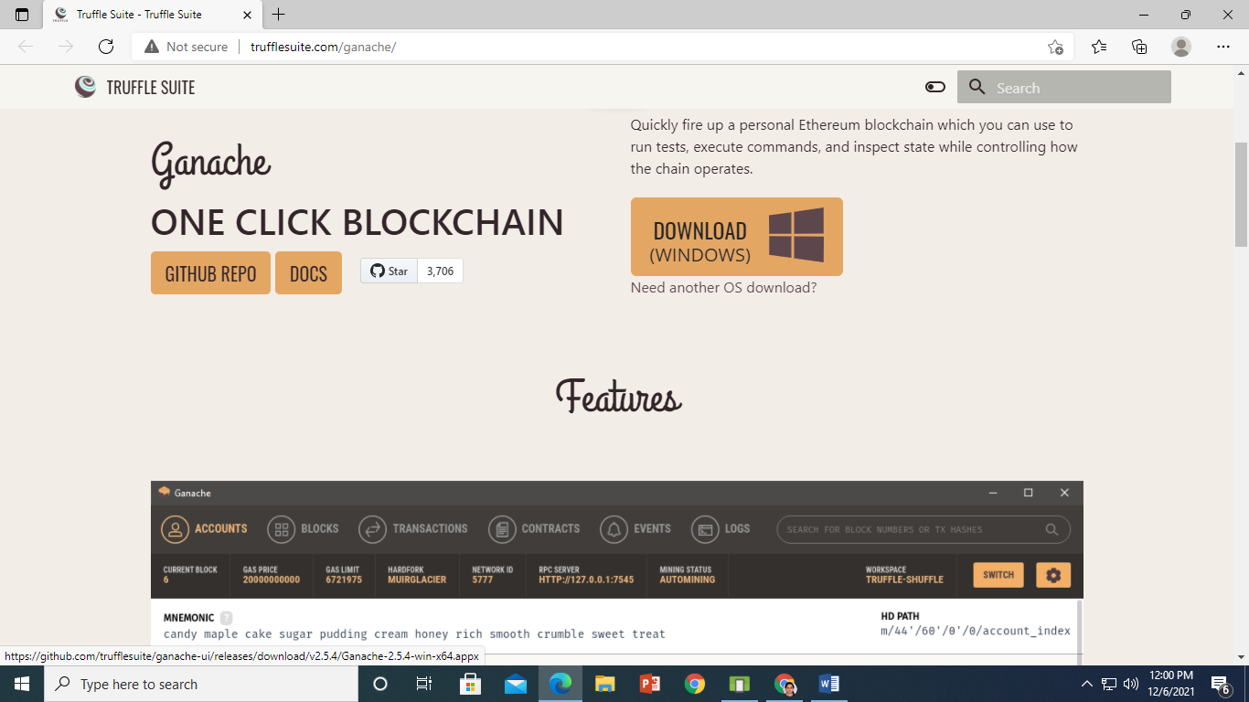

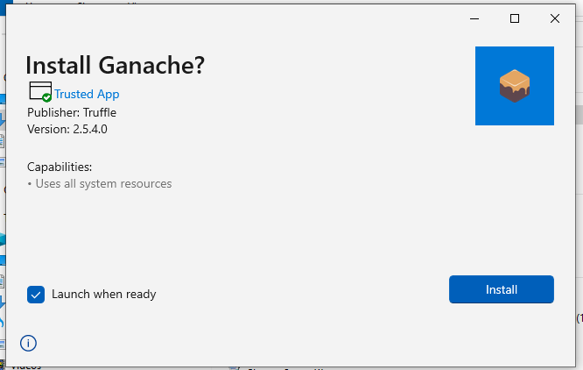

**Click on install**

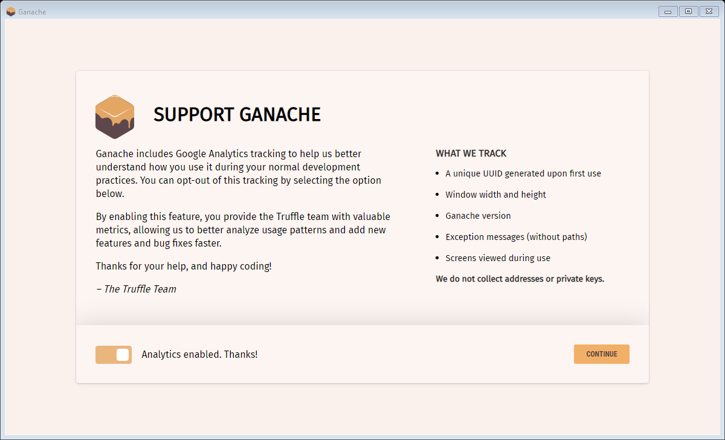

**Click on Continue**

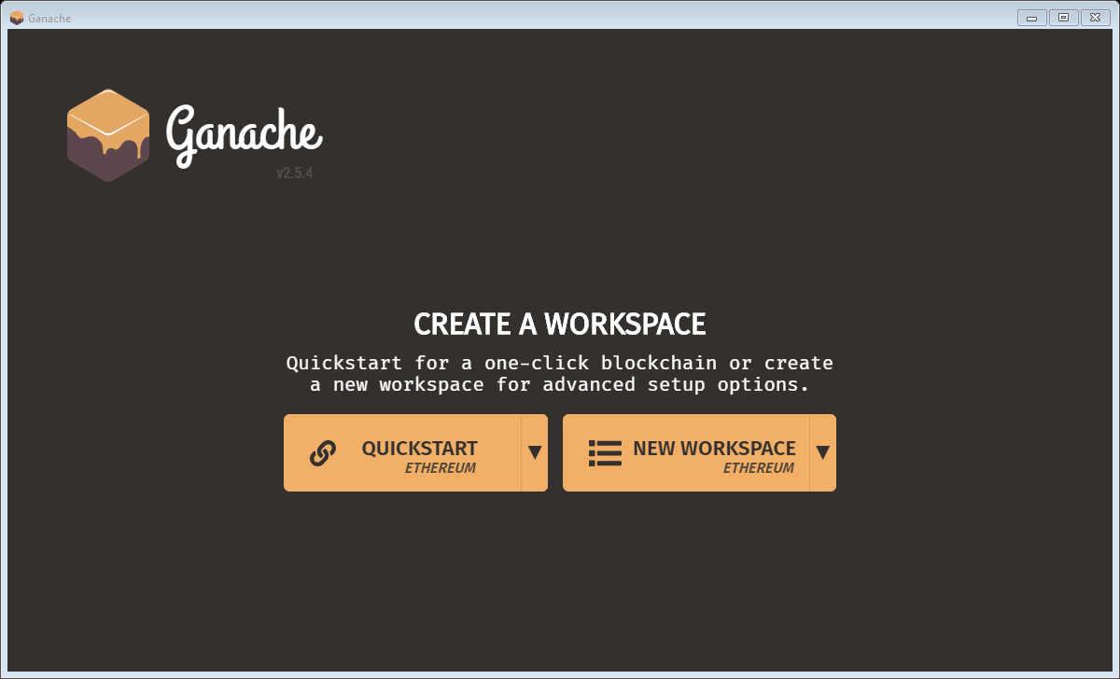

**Click on QuickStart**

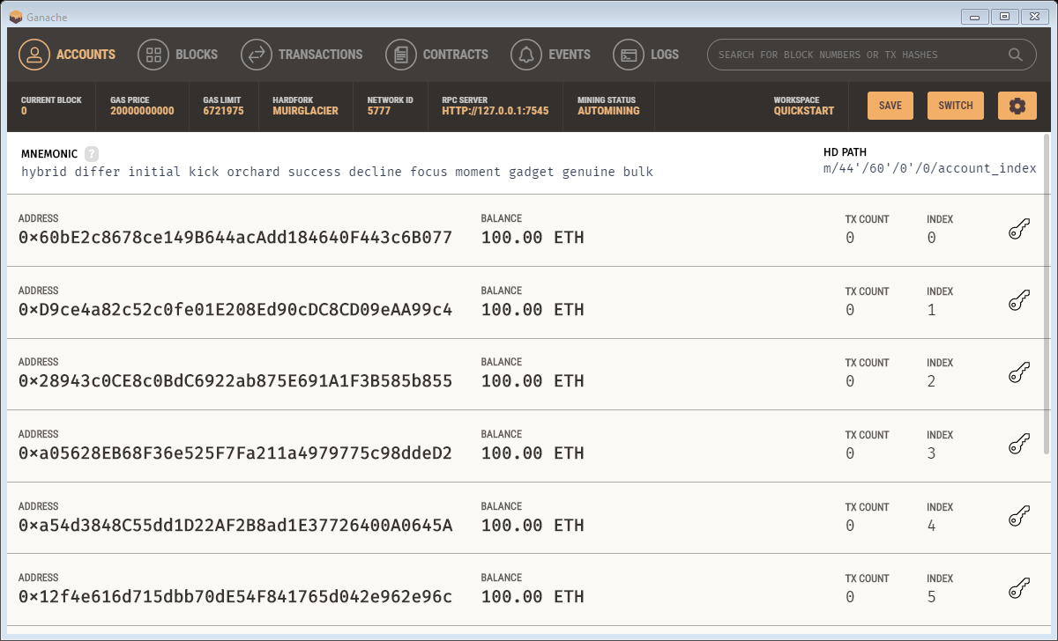

**Ganache Successfully installed. Now minimize Ganache.**

**STEP 2**

**SETUP A METAMASK ETHEREUM WALLET**

* MetaMask is just an Ethereum Browser and Ether wallet.
* It interacts with Ethereum Dapps and Smart Contracts without running a full Ethereum node.
* MetaMask add-on can be installed on Chrome, Firefox, Opera, and the new Brave browser.
* **URL:** [**https://metamask.io/**](https://metamask.io/)
* Install MetaMask
* Add MetaMask extension to the Browser
* MetaMask will show up 12 words recovery key (Seed).
* These 12 words are the only way to restore MetaMask accounts.

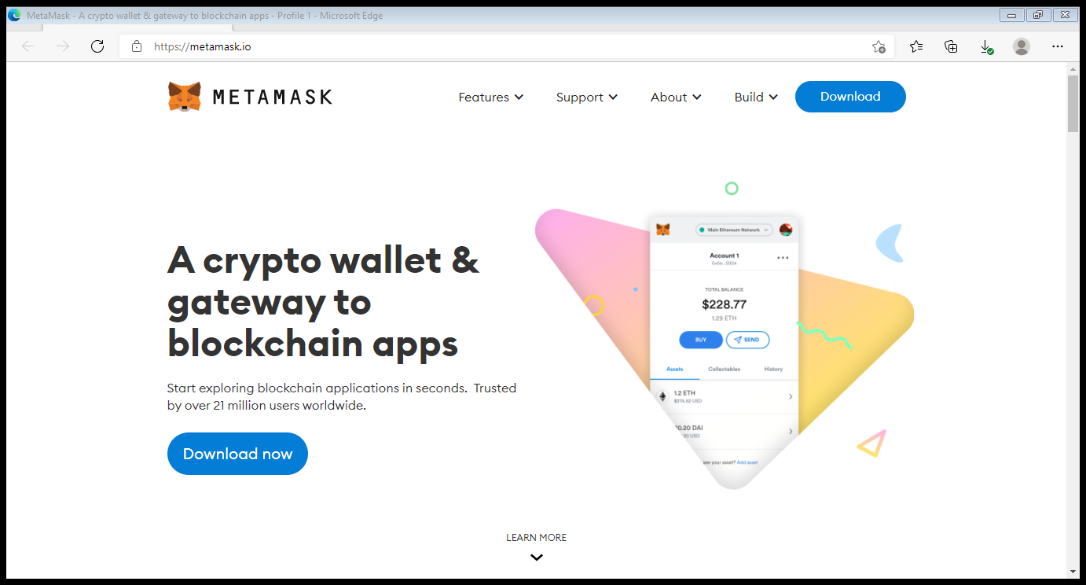

Click on download

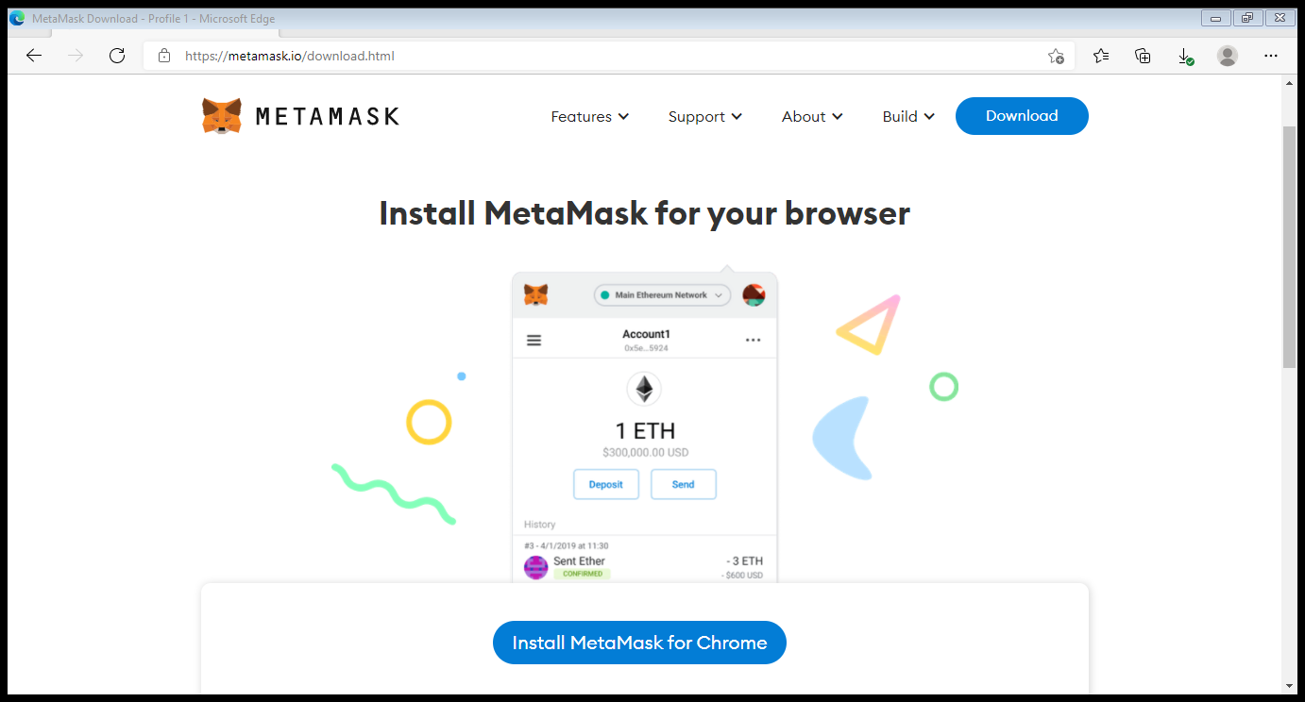

Click on Install MetaMask for Chrome.

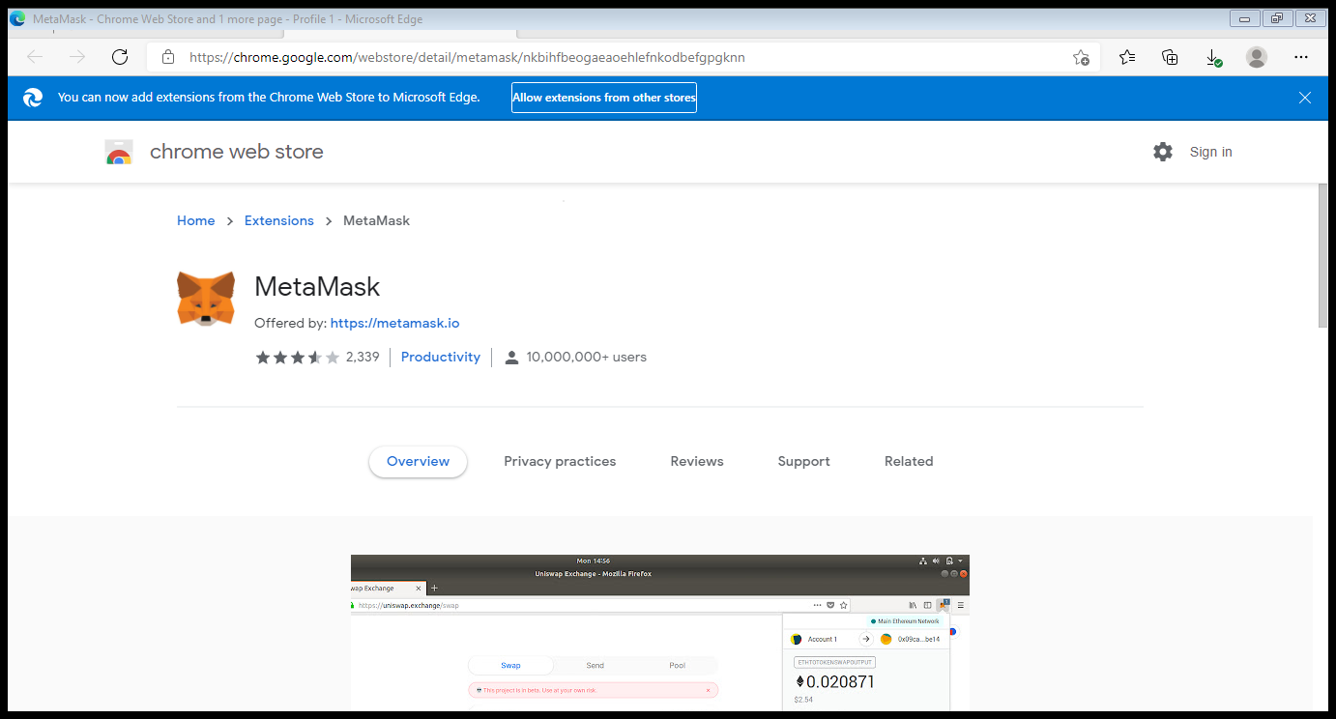

Click on Allow Extensions from other stores.

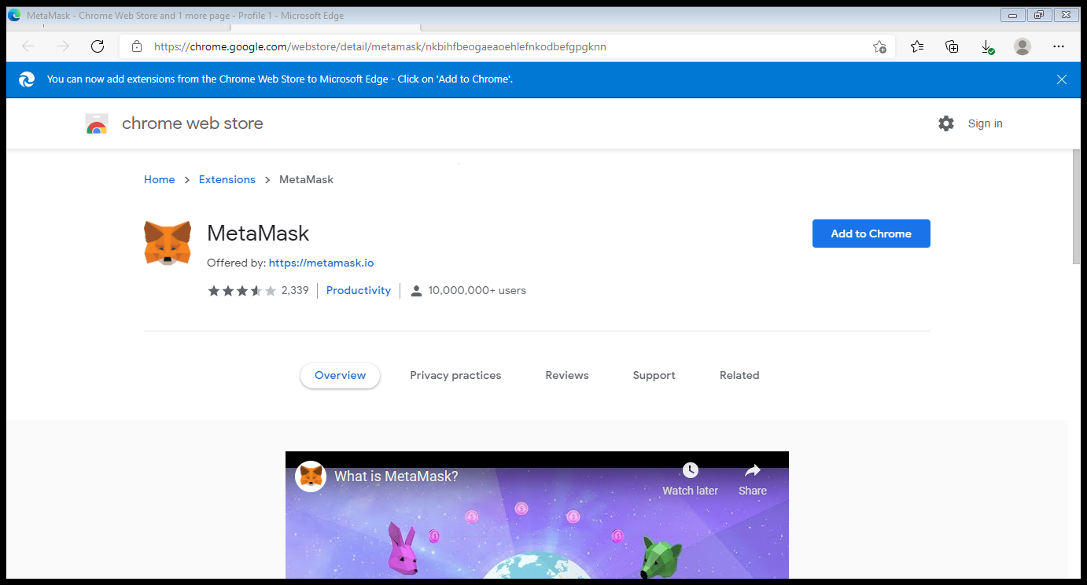

Click on Add to Chrome

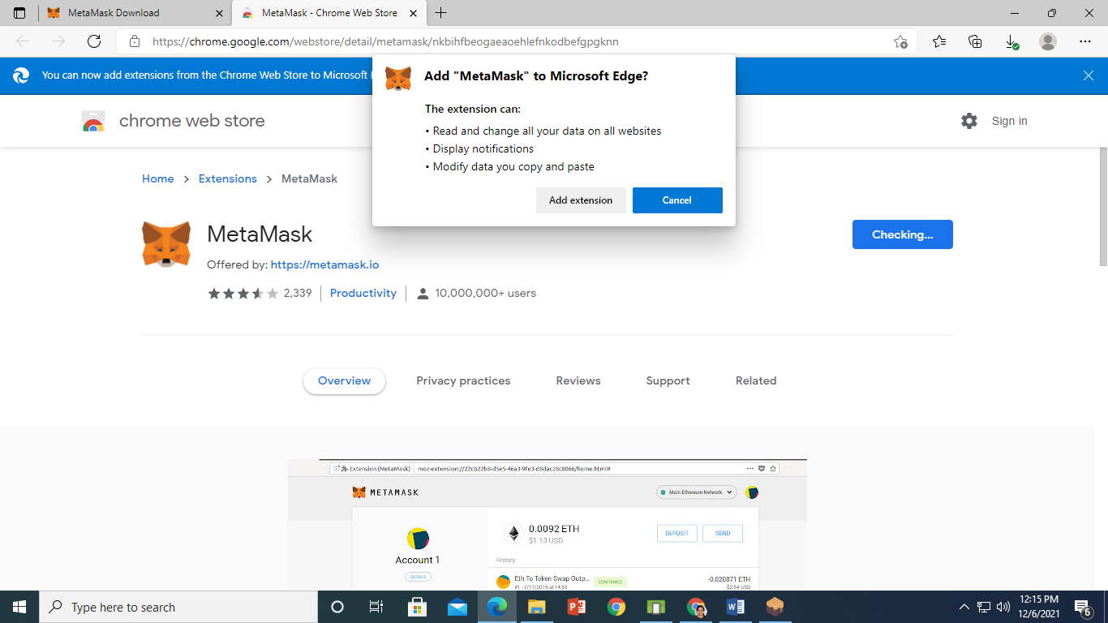

Click on Add extension

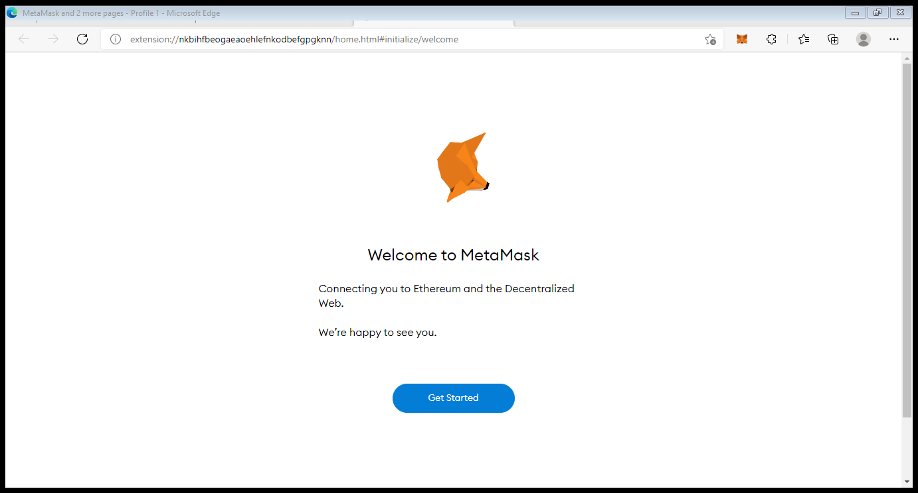

Click on Get Started

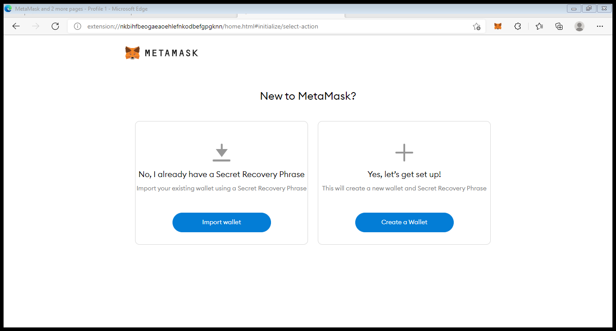

Click on Create Wallet

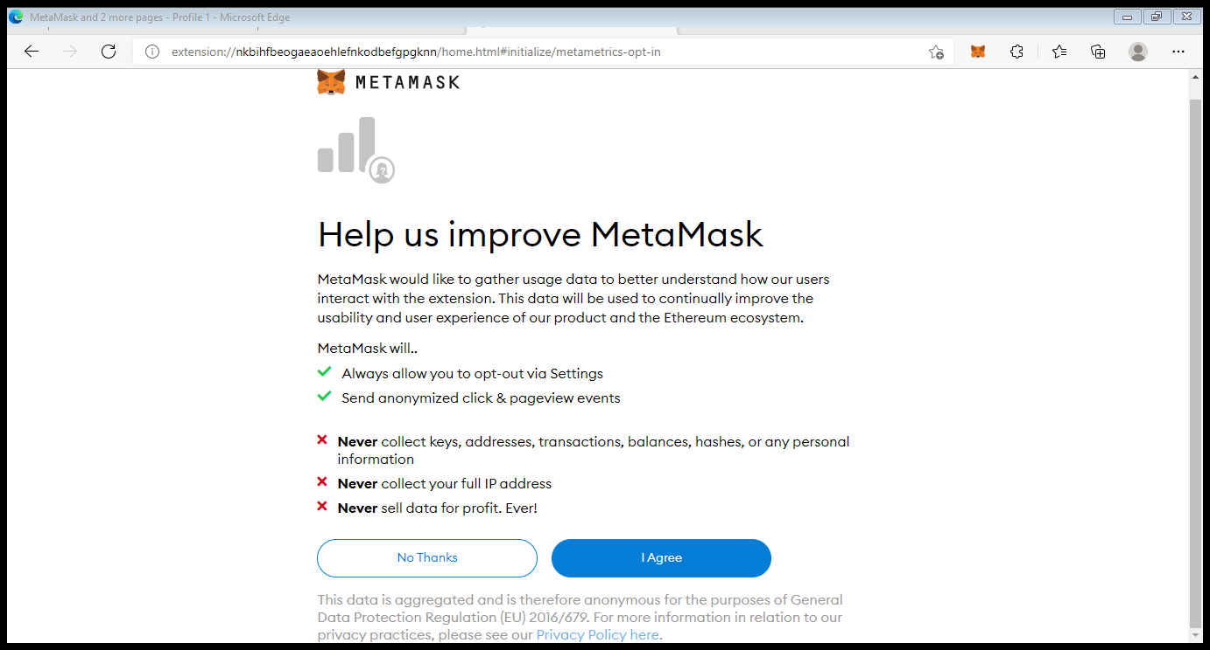

Click on I Agree

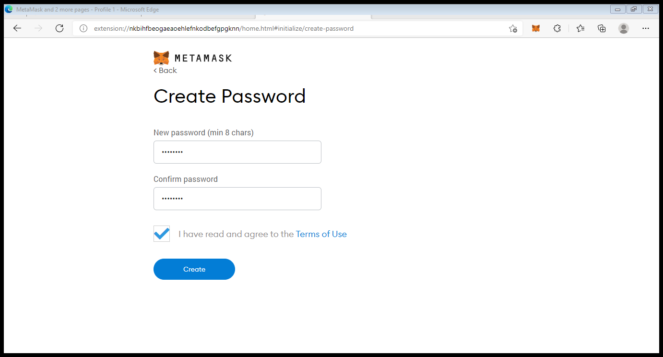

Mention password. Note down password further it is required and click on create.

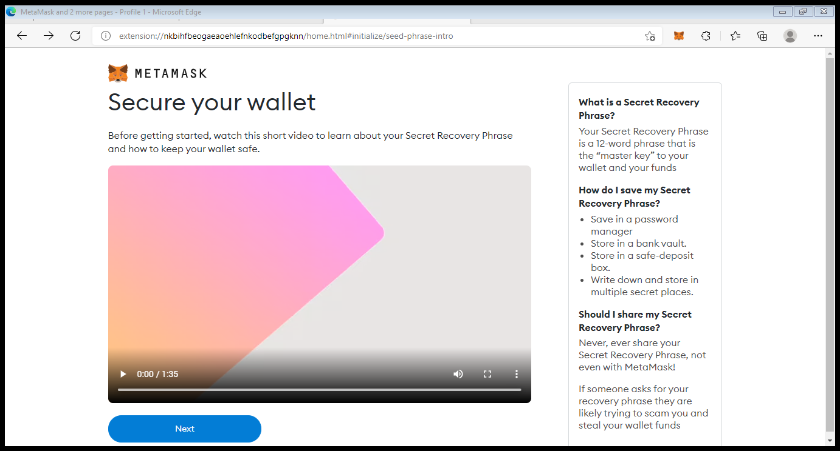

Click on Next.

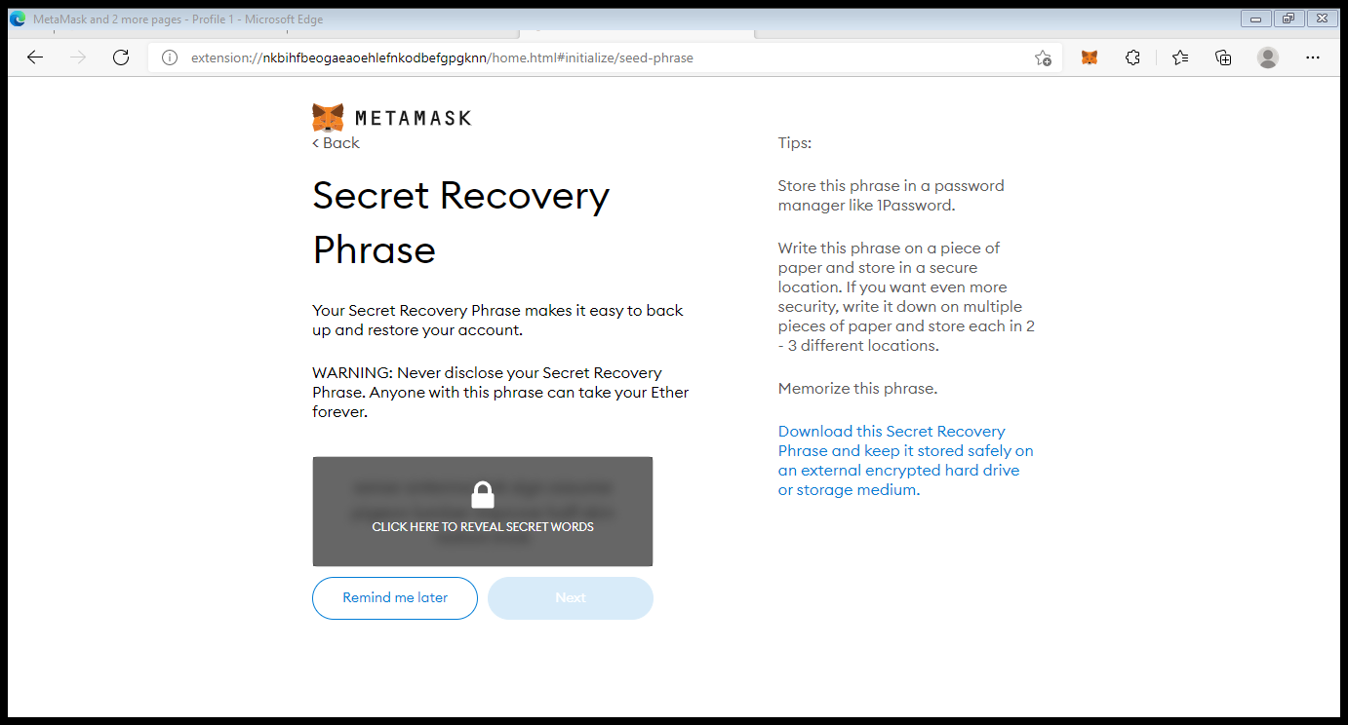

Click on Click here to reveal secret words.

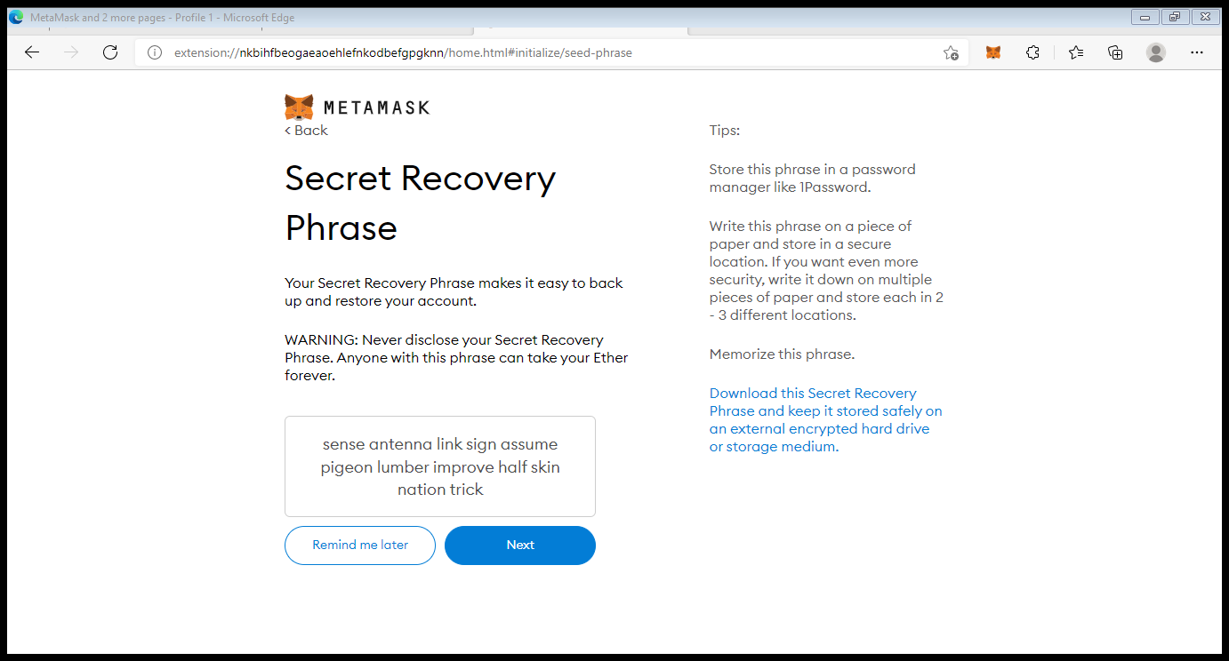

Copy all the words and save it in notepad. Then click on Next.

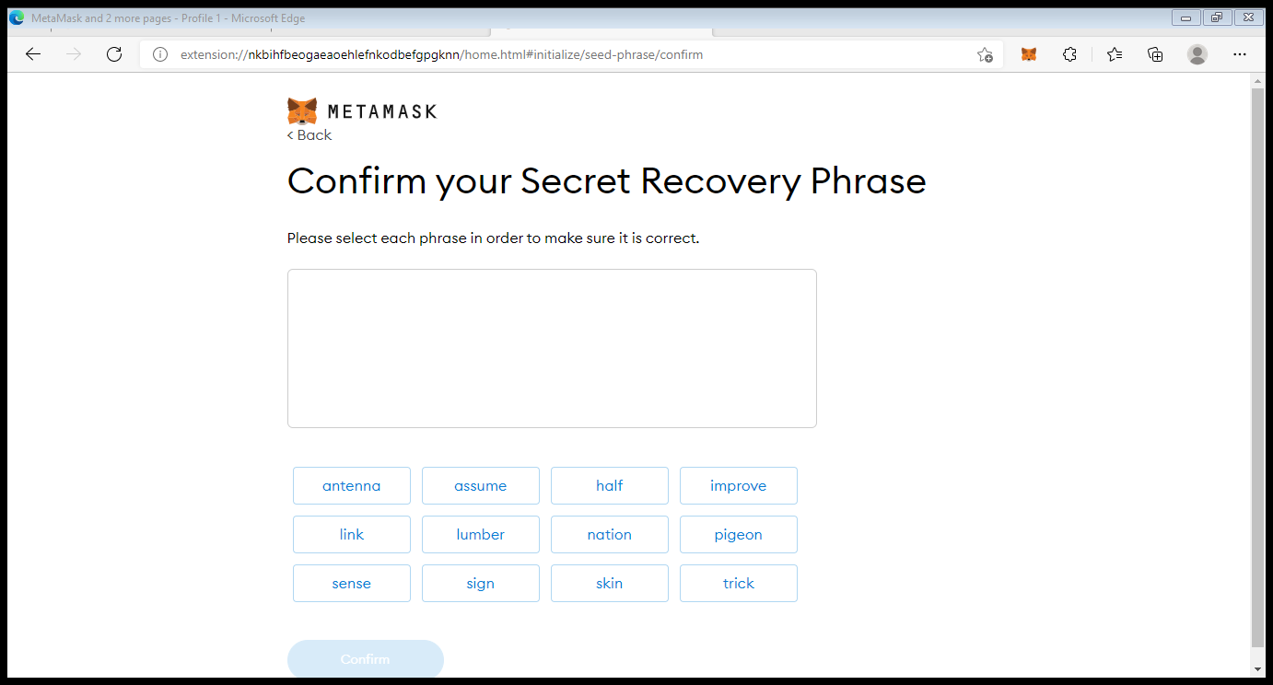

Refer the notepad and select the words in same sequence.

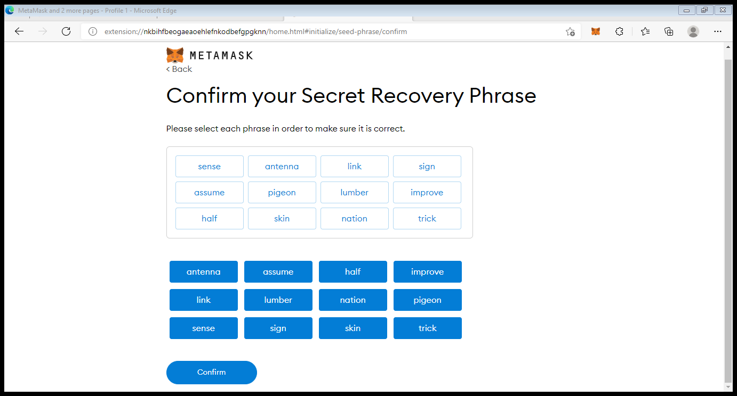

Click on confirm.

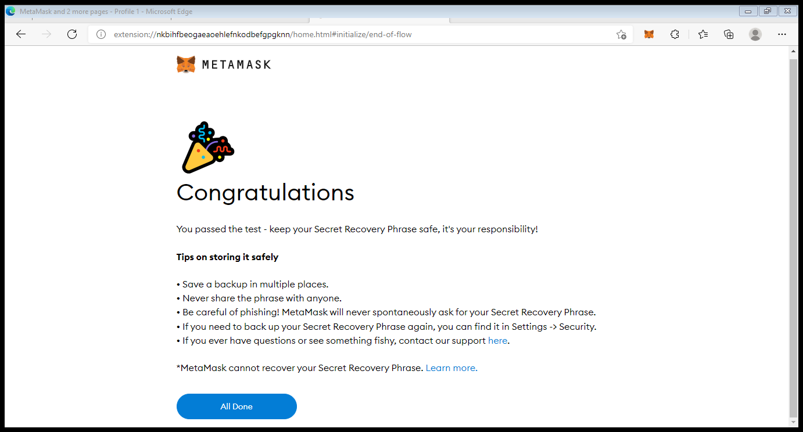

Click on All Done.

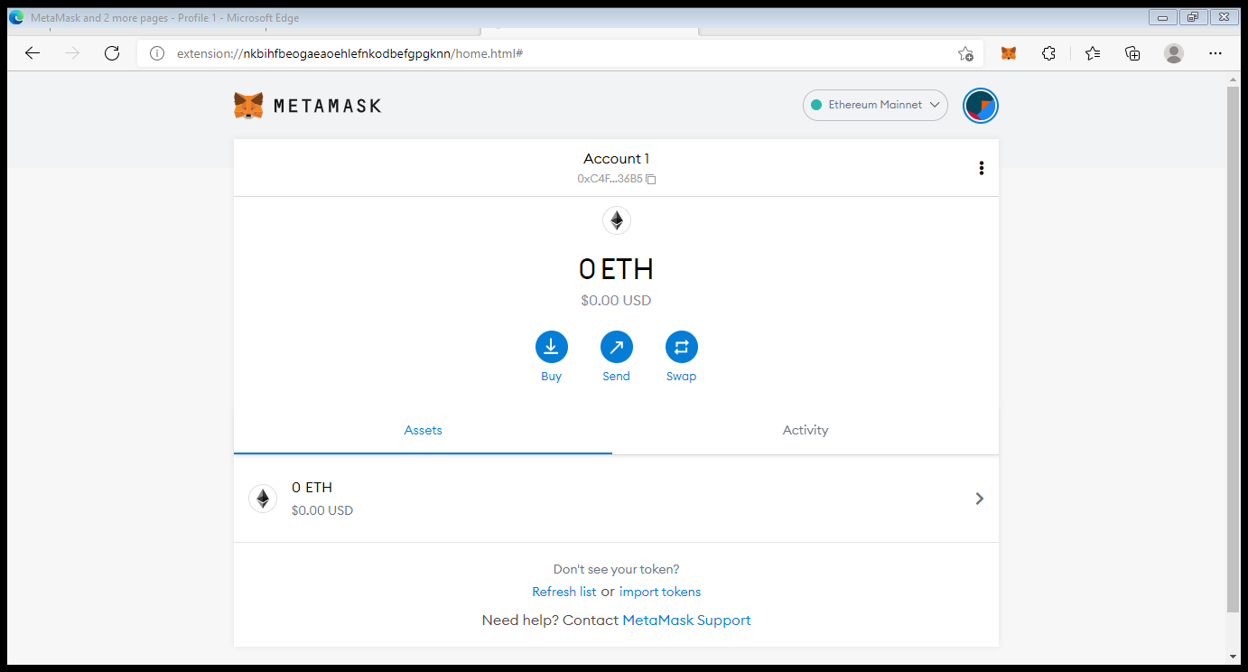

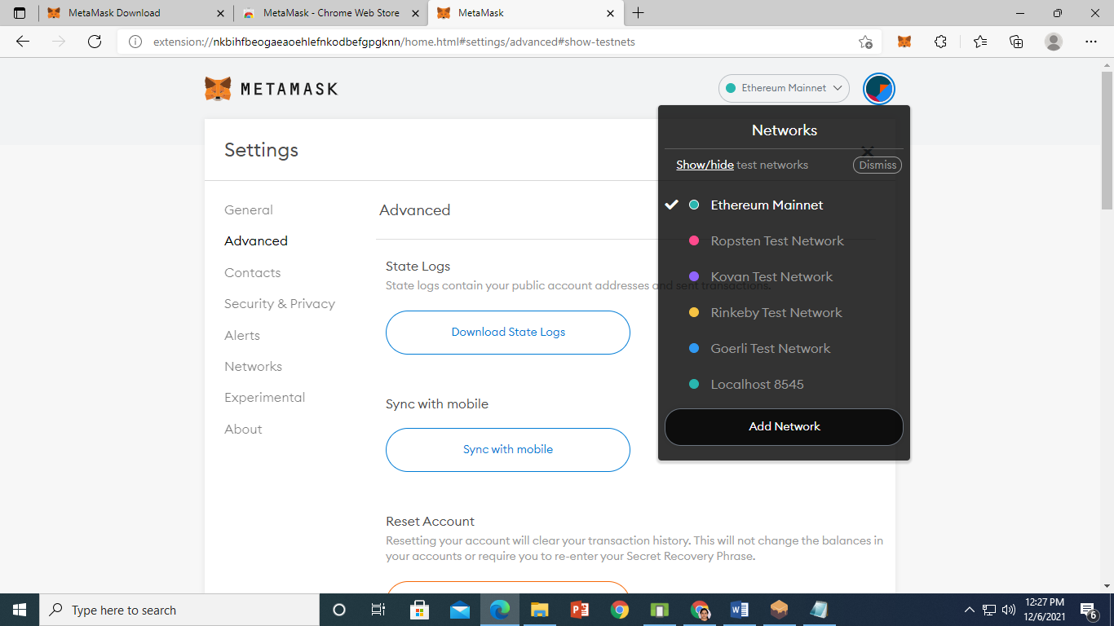

Click on Show/Hide test network.

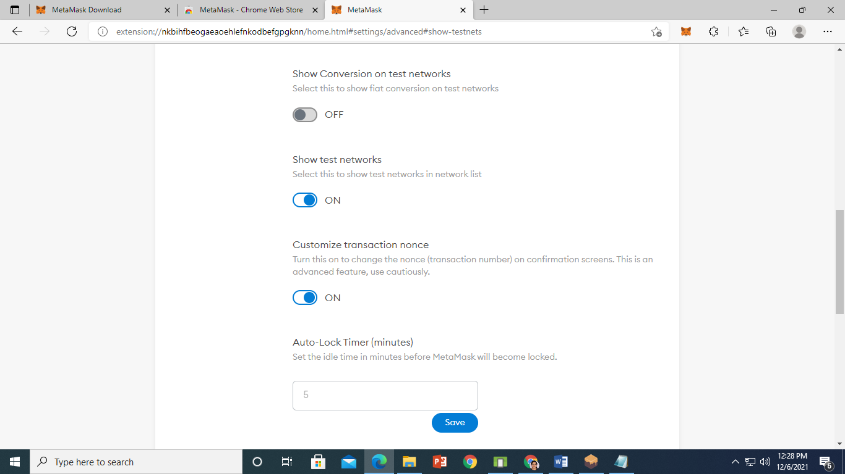

On show test network. scroll up and select dropdown list Ethereum Mainnet and click on Add Network

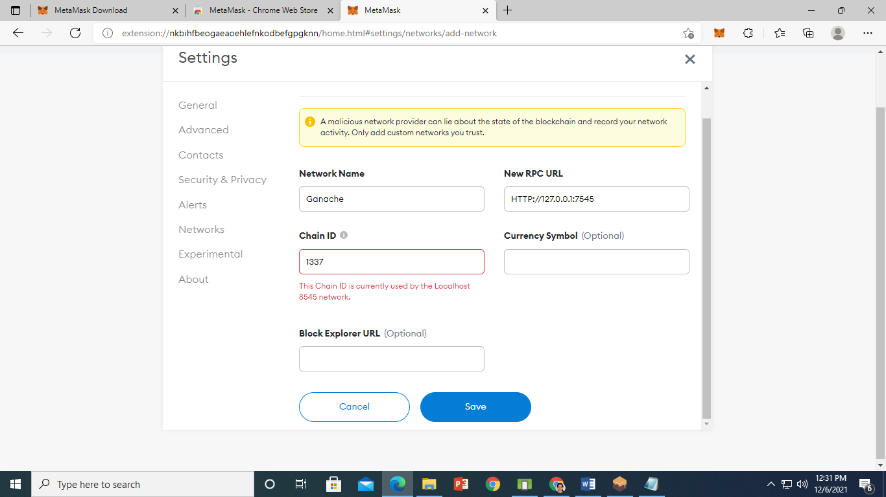

Click on save.

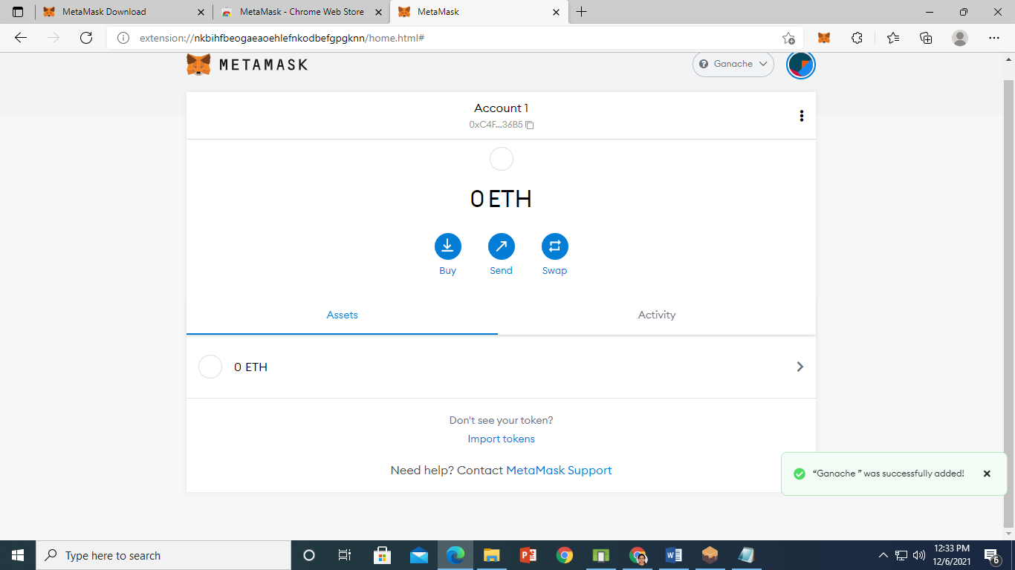

Ganache was successfully added.

**STEP 3**

On remix IDE Create Ethereum Smart Contract for Employee

pragma solidity >=0.4.22 <0.5.0;

contract Employee {

    string public EmployeeName;

    string public EmployeeAddress;

    string public EmployeeDepartment;

    uint256 public EmployeeID;

    uint256 public EmployeeServiceYears;

    constructor (string memory NewEmployeeName,string memory NewEmployeeAddress,string memory NewEmployeeDepartment,uint256 NewEmployeeID,uint256 NewEmployeeServiceYears)public{

        EmployeeName=NewEmployeeName;

        EmployeeAddress=NewEmployeeAddress;

        EmployeeDepartment=NewEmployeeDepartment;

        EmployeeID=NewEmployeeID;

        EmployeeServiceYears=NewEmployeeServiceYears;

    }

    function  SetEmployeeDepartment(string memory NewEmployeeDepartment) public{

        EmployeeDepartment=NewEmployeeDepartment;

    }

    function  SetEmployeeYears(uint256 NewEmployeeServiceYears) public{

        EmployeeServiceYears=NewEmployeeServiceYears;

    }

    function GetEmployeeData() public view returns (string memory ,string memory ,string memory ,uint256 ,uint256 ){

        return(EmployeeName,EmployeeAddress,EmployeeDepartment,EmployeeID,EmployeeServiceYears);

    }

}

Compile and then deploy.

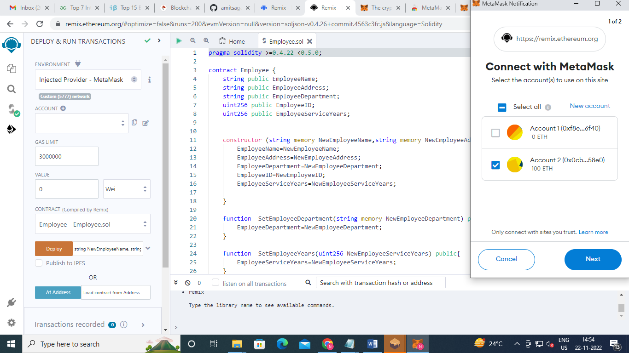

Click on next

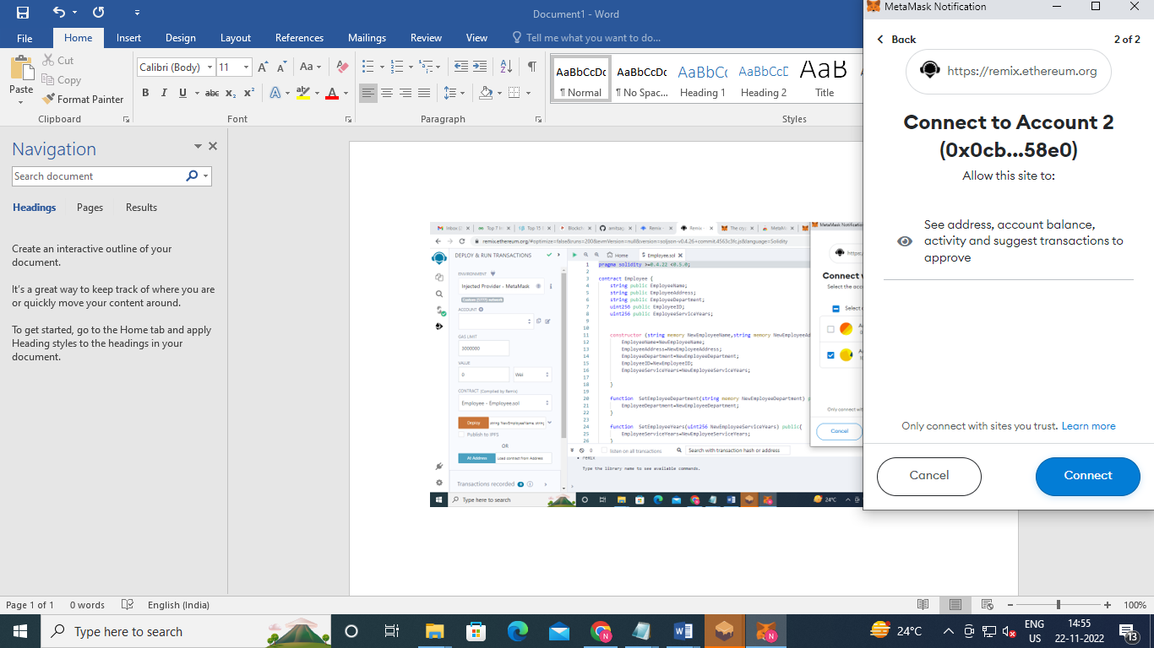

**Click on confirm and Expand dropdown list of deploy….. Enter all the details and then click on deploy.**

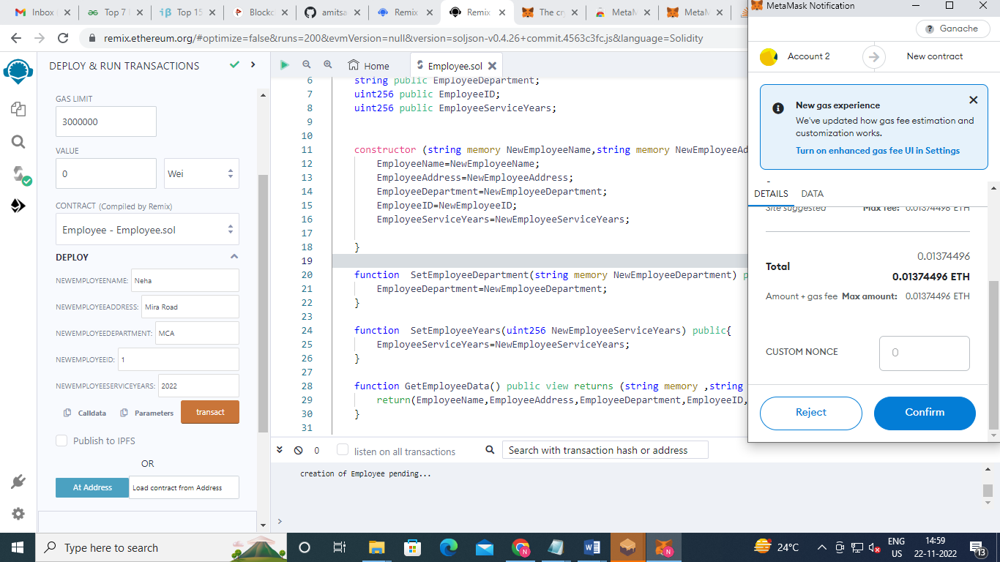

Click on confirm and then click on confirm……on metamask pop up window.

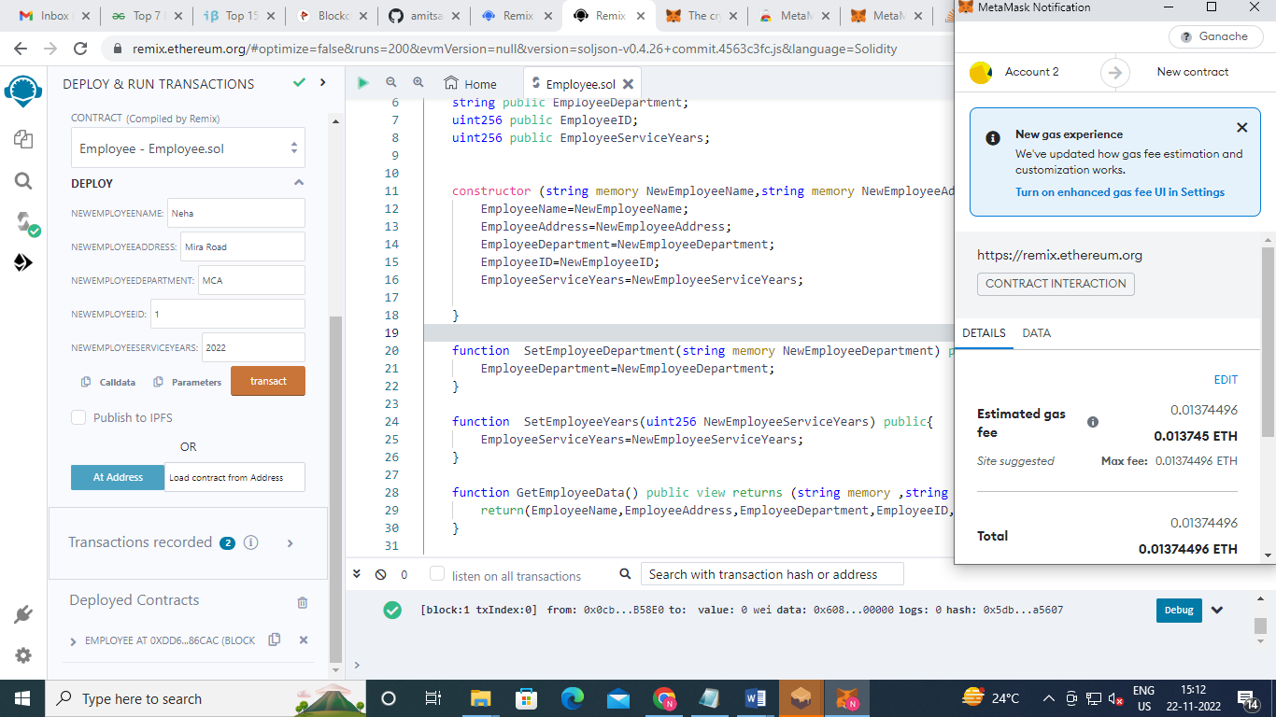

Click on transact

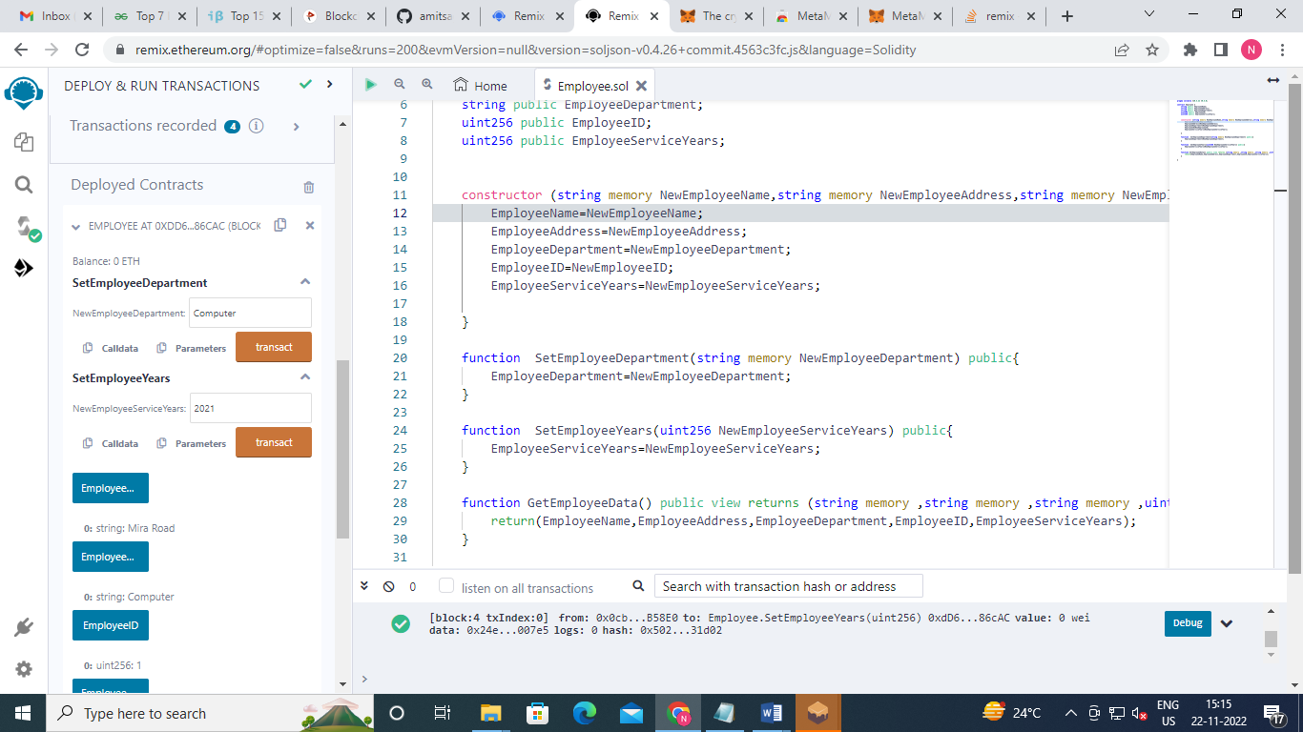

Click on transact and then click on confirm ….on metamask pop up.

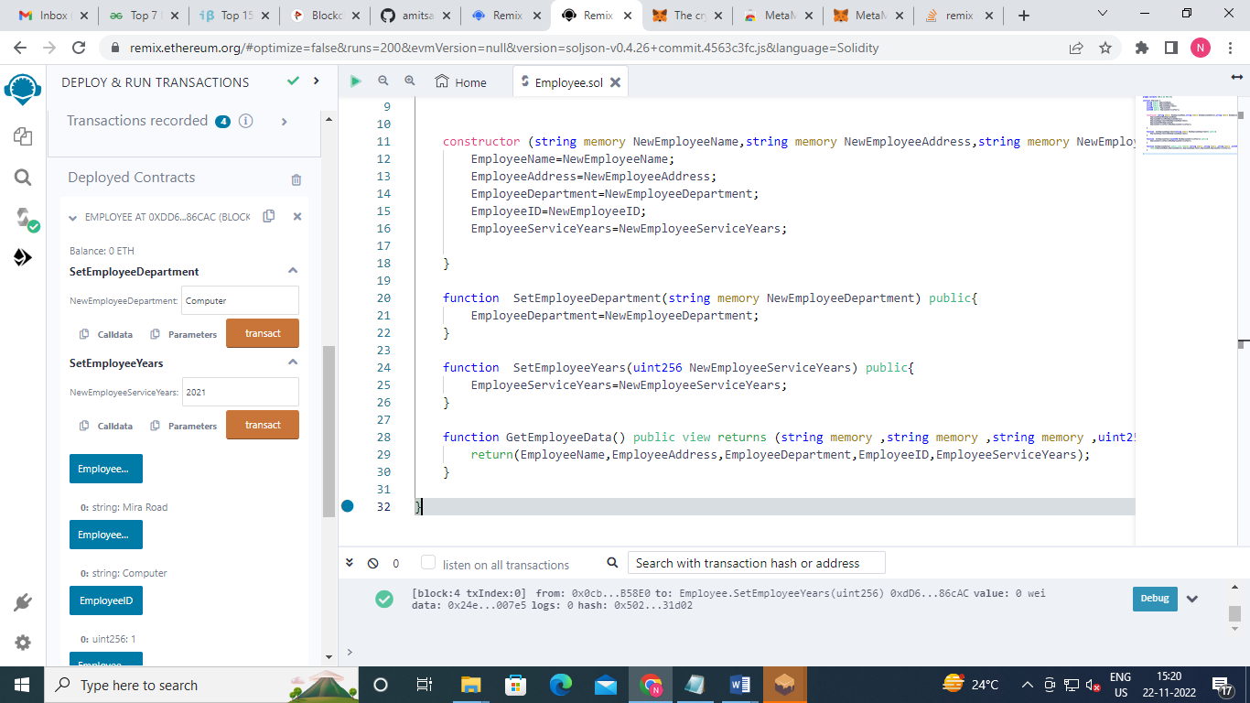

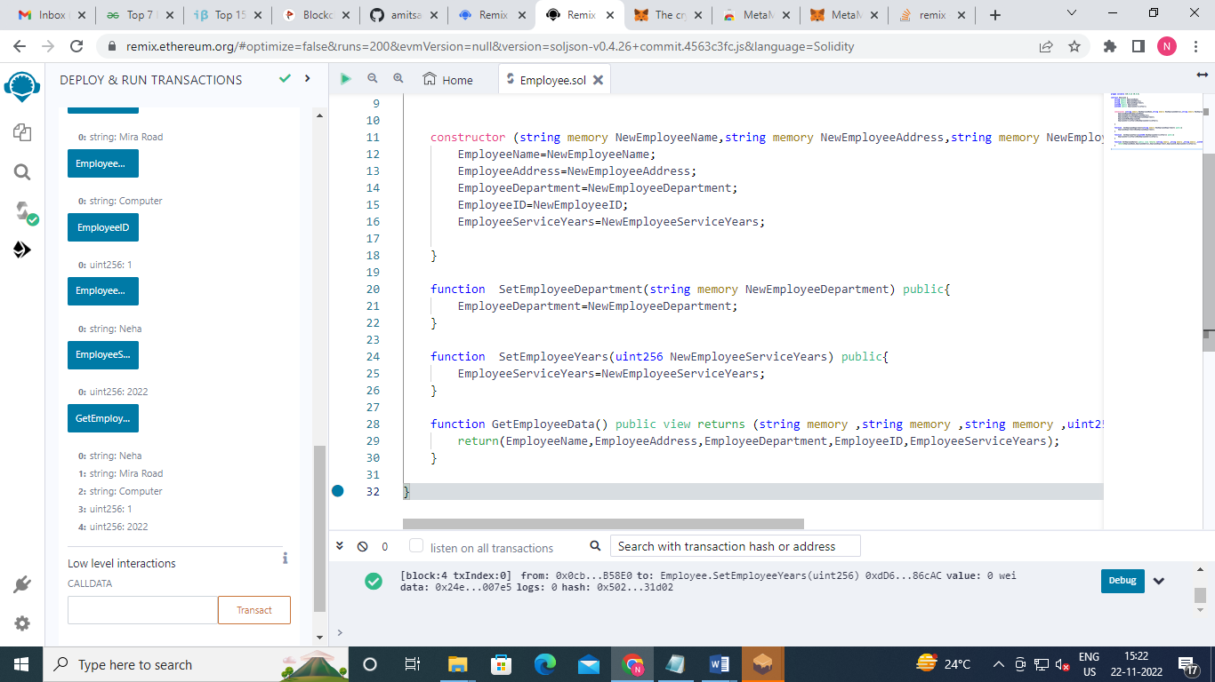

Metamask Activity

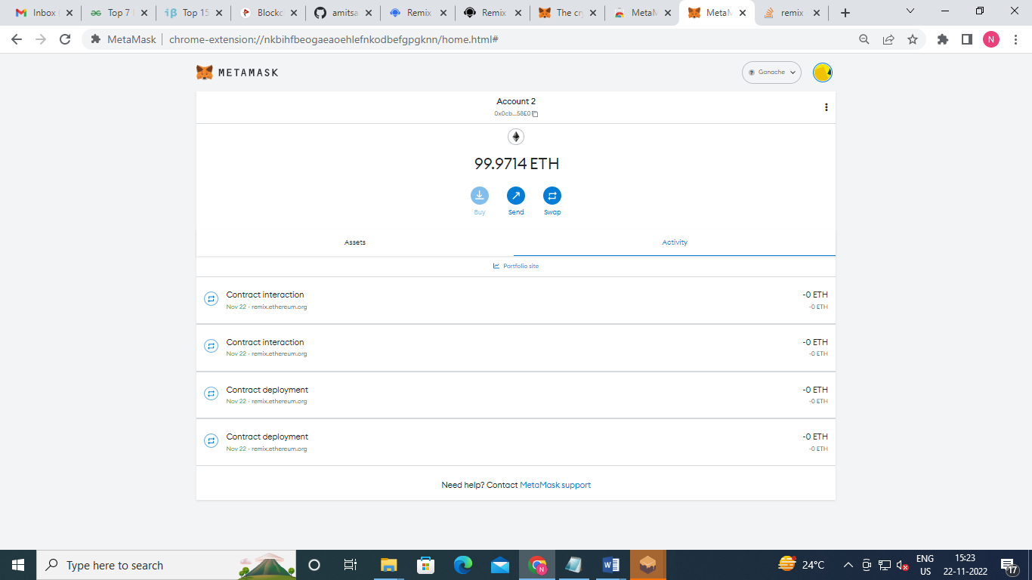

On Ganache

